Posted 08/14/2012 at 8:40 am by JAV

Town Hall Building Committee

DRAFT Agenda
Fireplace Room, Old Library
Thursday August 16, 2012
7:00 PM

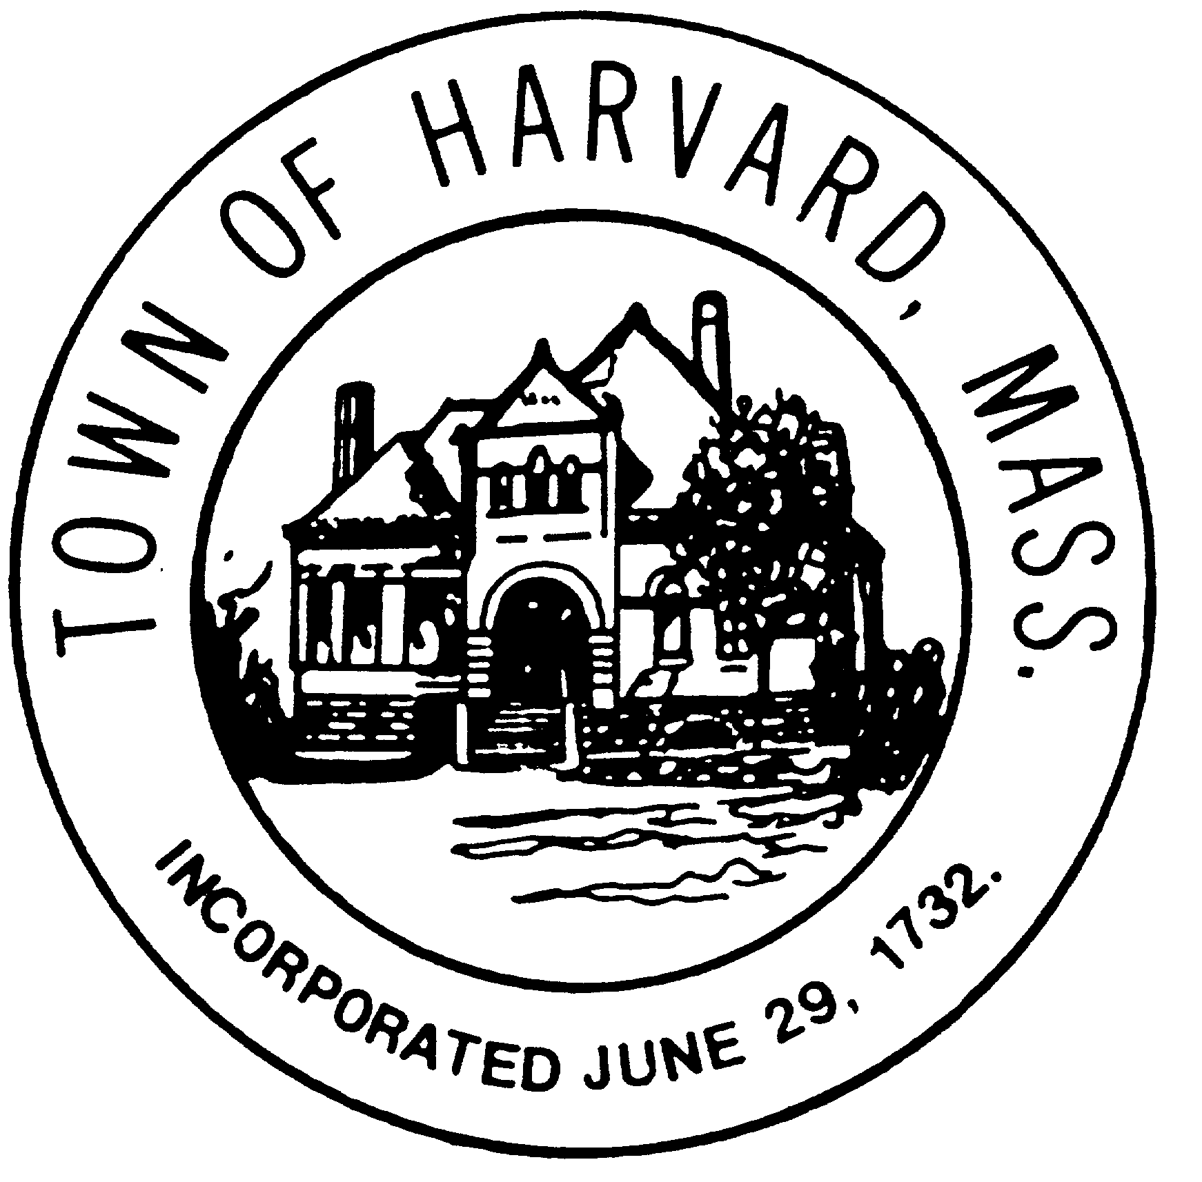
- Approve minutes

- Approve invoices

- Final approval of DTI and LLB agreements if needed

- Agenda and date for next meeting(s)

- New business

